Common bean

Table of Contents

## Load the working packages

library(AgroR)  
library(tidyverse)  
library(agricolae)  
library(lme4)  
library(emmeans)  
library(reshape)  
library(reshape2)  
library(car)

## Load the data

setwd("~/Code/R/SCASI")  
library(tidyverse)  
library(skimr)  
  
df <- readxl::read_excel("./input/SCASI_Field_Trials_Data_2022ALL_20230409_Adama_v2.xlsx",sheet = "MergePart2Part1")  
# First rows  
#knitr::kable(head(df))  
  
# Convert to factor  
df$Rep <- as.factor(df$Rep)  
df$Treatment <- as.factor(df$Treatment)  
df$Woreda <- as.factor(df$Woreda)

## Overview of the data

Number of observations and variables:

## [1] 709 153

## Extract data per crops

# crop_data  
crop_data <- df %>% filter(Plot_crop==params$crop)

## Descriptive statistics

### Yield accorss treatments

yield_trt_summary<- crop_data %>% group_by(Treatment) %>% summarize(across(.cols = c(GY_kg_ha,SY_kg_ha),list(min=min,max=max,mean=mean,sd=sd),na.rm=T,.names = "{.fn}_{.col}"))  
knitr::kable(yield_trt_summary)

|  |  |  |  |  |  |  |  |  |
| --- | --- | --- | --- | --- | --- | --- | --- | --- |
| Treatment | min_GY_kg_ha | max_GY_kg_ha | mean_GY_kg_ha | sd_GY_kg_ha | min_SY_kg_ha | max_SY_kg_ha | mean_SY_kg_ha | sd_SY_kg_ha |
| 1 | 100 | 3000 | 863.0000 | 743.2763 | 75 | 2000 | 693.8333 | 591.2825 |
| 2 | 200 | 3000 | 1222.8333 | 708.5995 | 350 | 5500 | 1130.0000 | 1032.0594 |
| 3 | 200 | 2300 | 986.6667 | 569.1317 | 150 | 2500 | 780.8333 | 539.0638 |
| 4 | 150 | 3750 | 1172.5000 | 753.7650 | 200 | 2800 | 906.0000 | 547.7956 |
| 5 | 95 | 2500 | 693.1667 | 606.4900 | 50 | 4000 | 723.0000 | 931.9516 |
| 6 | 100 | 2750 | 848.6667 | 634.6855 | 75 | 3000 | 737.1667 | 597.0628 |
| 7 | 150 | 4850 | 958.1667 | 876.8866 | 250 | 5000 | 949.8333 | 1087.2755 |

#yield_trt_summary  
#with(crop_data, desc(Treatment, GrainYield, ylab = "Grain Yield ", xlab = "Treatment", ylim = NA))  
  
#boxplot  
crop_data %>% select(GY_kg_ha, SY_kg_ha, Treatment) %>% gather(key = "Yields",value= "Value", -Treatment) %>%   
ggplot(aes(x=Treatment,y=Value, fill=Yields)) +  
 geom_boxplot() +  
 scale_fill_manual(values = c("GY_kg_ha" = "#dfc27d", "SY_kg_ha" = "#80cdc1"), labels=c("Grain", "Stover")) +  
 labs(y="Yield (Kg/ha)")+  
 theme_bw()+  
 theme(legend.title = element_text(size = 18),  
 legend.text = element_text(size = 16),  
 axis.title = element_text(size = 24),  
 axis.text = element_text(size = 20))

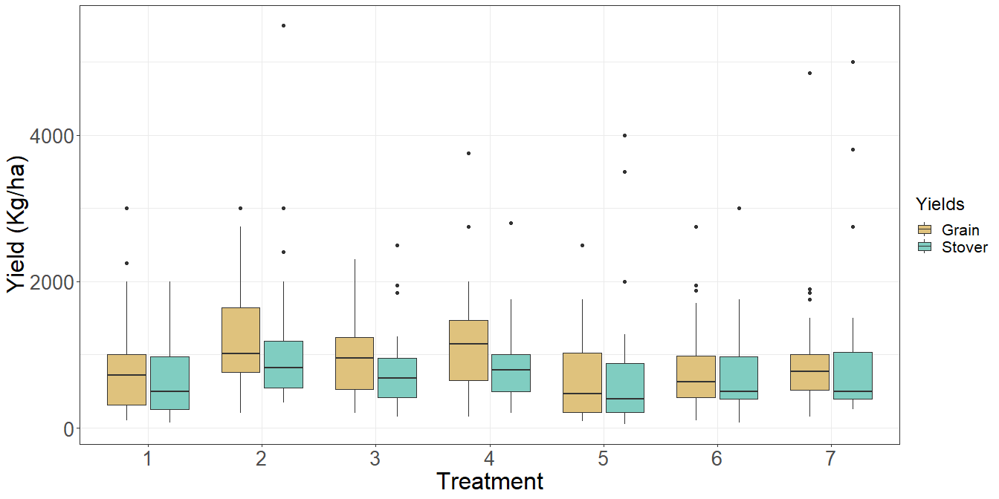

### Yield accorss locations

yield_location<- crop_data %>% group_by(Woreda) %>% summarize(across(.cols = c(GY_kg_ha,SY_kg_ha),list(min=min,max=max,mean=mean,sd=sd),na.rm=T,.names = "{.fn}_{.col}"))  
knitr::kable(yield_location)

|  |  |  |  |  |  |  |  |  |
| --- | --- | --- | --- | --- | --- | --- | --- | --- |
| Woreda | min_GY_kg_ha | max_GY_kg_ha | mean_GY_kg_ha | sd_GY_kg_ha | min_SY_kg_ha | max_SY_kg_ha | mean_SY_kg_ha | sd_SY_kg_ha |
| Boloso Bombe | 95 | 2250 | 932.8571 | 565.6101 | 50 | 2000 | 721.0952 | 459.4871 |
| Boloso Sore | 100 | 4850 | 994.2857 | 842.7717 | 75 | 5500 | 970.5238 | 1015.3848 |

#yield_trt_summary  
#with(crop_data, desc(Treatment, GrainYield, ylab = "Grain Yield ", xlab = "Treatment", ylim = NA))  
  
#boxplot  
crop_data %>% select(GY_kg_ha, SY_kg_ha, Woreda) %>% gather(key = "Yields",value= "Value", -Woreda) %>%   
ggplot(aes(x=Woreda,y=Value, fill=Yields)) +  
 geom_boxplot() +  
 scale_fill_manual(values = c("GY_kg_ha" = "#d01c8b", "SY_kg_ha" = "#4dac26"), labels=c("Grain", "Stover")) +  
 labs(y="Yield (Kg/ha)")+  
 theme_bw()+  
 theme(legend.title = element_text(size = 18),  
 legend.text = element_text(size = 16),  
 axis.title = element_text(size = 24),  
 axis.text = element_text(size = 20))

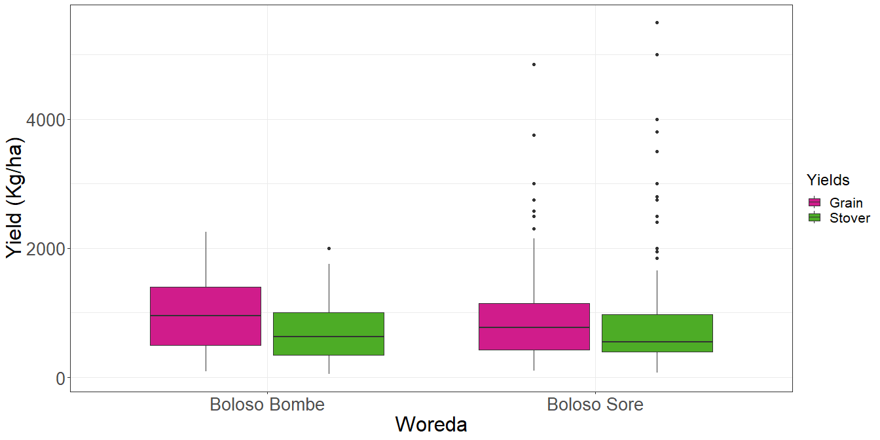

### Yield accorss locations and treatments

* Summary table

yield_location_trt<- crop_data %>% select(GY_kg_ha, SY_kg_ha, Woreda,Treatment) %>% group_by(Woreda,Treatment) %>% summarize(across(.cols = c(GY_kg_ha, SY_kg_ha),list(min=min,max=max,mean=mean,sd=sd),na.rm=T,.names = "{.fn}_{.col}"))

## `summarise()` has grouped output by 'Woreda'. You can override using the `.groups` argument.

knitr::kable(yield_location_trt)

|  |  |  |  |  |  |  |  |  |  |
| --- | --- | --- | --- | --- | --- | --- | --- | --- | --- |
| Woreda | Treatment | min_GY_kg_ha | max_GY_kg_ha | mean_GY_kg_ha | sd_GY_kg_ha | min_SY_kg_ha | max_SY_kg_ha | mean_SY_kg_ha | sd_SY_kg_ha |
| Boloso Bombe | 1 | 100 | 2250 | 736.3333 | 662.9600 | 100 | 2000 | 599.3333 | 577.0054 |
| Boloso Bombe | 2 | 400 | 1900 | 1166.6667 | 507.4153 | 350 | 2000 | 983.3333 | 496.2958 |
| Boloso Bombe | 3 | 350 | 1900 | 1098.3333 | 491.9410 | 150 | 1250 | 681.6667 | 349.8044 |
| Boloso Bombe | 4 | 250 | 2000 | 1155.0000 | 489.0041 | 300 | 1750 | 973.3333 | 452.3221 |
| Boloso Bombe | 5 | 95 | 1650 | 602.0000 | 517.0272 | 50 | 1250 | 430.0000 | 361.4455 |
| Boloso Bombe | 6 | 200 | 1950 | 906.6667 | 585.6915 | 300 | 1750 | 719.6667 | 399.1082 |
| Boloso Bombe | 7 | 150 | 1900 | 865.0000 | 531.9069 | 250 | 1450 | 660.3333 | 343.6592 |
| Boloso Sore | 1 | 150 | 3000 | 989.6667 | 818.8308 | 75 | 2000 | 788.3333 | 610.0254 |
| Boloso Sore | 2 | 200 | 3000 | 1279.0000 | 880.8300 | 425 | 5500 | 1276.6667 | 1383.4631 |
| Boloso Sore | 3 | 200 | 2300 | 875.0000 | 634.2177 | 200 | 2500 | 880.0000 | 677.1263 |
| Boloso Sore | 4 | 150 | 3750 | 1190.0000 | 968.0522 | 200 | 2800 | 838.6667 | 638.1879 |
| Boloso Sore | 5 | 190 | 2500 | 784.3333 | 690.5119 | 125 | 4000 | 1016.0000 | 1218.4009 |
| Boloso Sore | 6 | 100 | 2750 | 790.6667 | 695.8316 | 75 | 3000 | 754.6667 | 760.5836 |
| Boloso Sore | 7 | 200 | 4850 | 1051.3333 | 1136.3357 | 250 | 5000 | 1239.3333 | 1466.6566 |

#yield_trt_summary  
#with(crop_data, desc(Treatment, GrainYield, ylab = "Grain Yield ", xlab = "Treatment", ylim = NA))

* Grain

#boxplot  
crop_data %>% select(GY_kg_ha, Woreda,Treatment) %>%   
ggplot(aes(x=Treatment,y=GY_kg_ha, fill=Woreda)) +  
 geom_boxplot() +  
 scale_fill_brewer(palette = "Set1") +  
 labs(y="Grain Yield (kg/ha)")+  
 theme_bw()+  
 theme(legend.title = element_text(size = 18),  
 legend.text = element_text(size = 16),  
 axis.title = element_text(size = 24),  
 axis.text = element_text(size = 20))

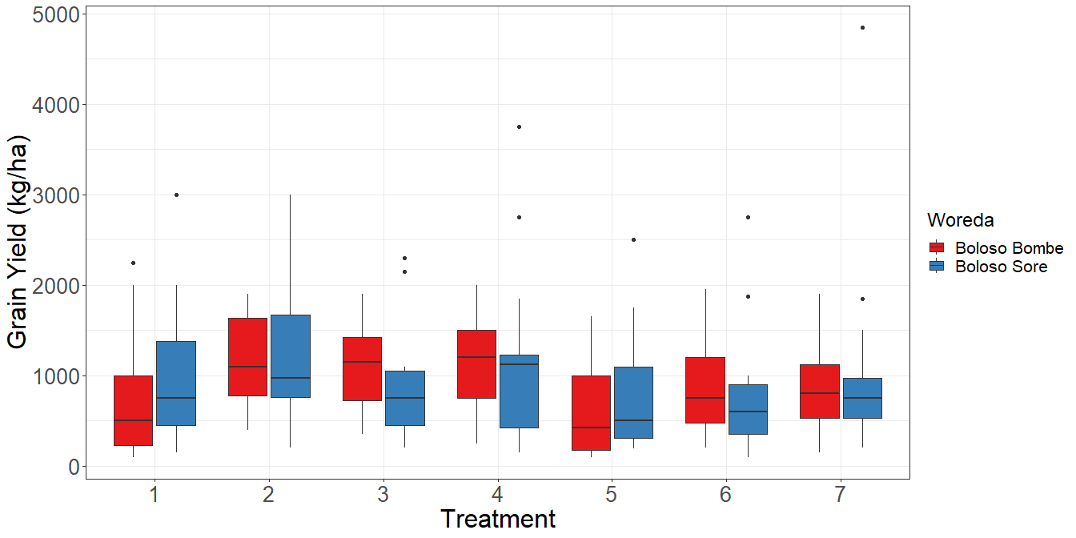

* Stover

#boxplot  
crop_data %>% select(SY_kg_ha, Woreda,Treatment) %>%   
ggplot(aes(x=Treatment,y=SY_kg_ha, fill=Woreda)) +  
 geom_boxplot() +  
 scale_fill_brewer(palette = "Set2") +  
 labs(y="Grain Yield (kg/ha)")+  
 theme_bw()+  
 theme(legend.title = element_text(size = 18),  
 legend.text = element_text(size = 16),  
 axis.title = element_text(size = 24),  
 axis.text = element_text(size = 20))

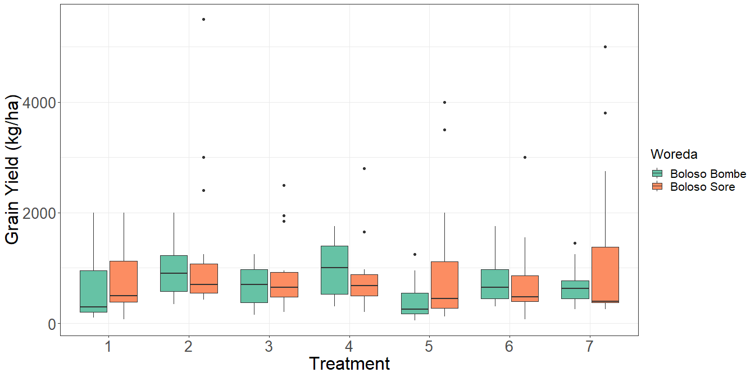

## Factorial analysis

# Analysis of variance  
  
#  
if (length(unique(crop_data$Woreda))<=1) {  
 model <- lm(GY_kg_ha~ Treatment, data=crop_data)  
 anova(model)  
} else {  
 model <- lm(GY_kg_ha~ Treatment + Woreda + (Treatment:Woreda) + (Woreda:Rep),data=crop_data)  
 anova(model)  
}

## Analysis of Variance Table  
##   
## Response: GY_kg_ha  
## Df Sum Sq Mean Sq F value Pr(>F)   
## Treatment 6 6236008 1039335 2.0927 0.05584 .  
## Woreda 1 198107 198107 0.3989 0.52841   
## Treatment:Woreda 6 1371800 228633 0.4604 0.83700   
## Woreda:Rep 4 4174907 1043727 2.1016 0.08217 .  
## Residuals 192 95355899 496645   
## ---  
## Signif. codes: 0 '***' 0.001 '**' 0.01 '*' 0.05 '.' 0.1 ' ' 1

## Posthoc test

# Compute the estimated marginal means  
emmeans_result <- emmeans(model, ~ Treatment)

## NOTE: A nesting structure was detected in the fitted model:  
## Rep %in% Woreda

## NOTE: Results may be misleading due to involvement in interactions

# Perform pairwise comparisons using Tukey's adjustment  
pairwise_result <- pairs(emmeans_result, adjust = "tukey")  
  
# Display the pairwise comparisons  
knitr::kable(pairwise_result)

|  |  |  |  |  |  |
| --- | --- | --- | --- | --- | --- |
| contrast | estimate | SE | df | t.ratio | p.value |
| Treatment1 - Treatment2 | -347.01833 | 182.0974 | 192 | -1.9056742 | 0.4790946 |
| Treatment1 - Treatment3 | -123.66667 | 181.9607 | 192 | -0.6796340 | 0.9935797 |
| Treatment1 - Treatment4 | -309.50000 | 181.9607 | 192 | -1.7009170 | 0.6162890 |
| Treatment1 - Treatment5 | 169.83333 | 181.9607 | 192 | 0.9333519 | 0.9667127 |
| Treatment1 - Treatment6 | 14.33333 | 181.9607 | 192 | 0.0787716 | 1.0000000 |
| Treatment1 - Treatment7 | -95.16667 | 181.9607 | 192 | -0.5230068 | 0.9984945 |
| Treatment2 - Treatment3 | 223.35166 | 182.0974 | 192 | 1.2265505 | 0.8830682 |
| Treatment2 - Treatment4 | 37.51833 | 182.0974 | 192 | 0.2060344 | 0.9999935 |
| Treatment2 - Treatment5 | 516.85166 | 182.0974 | 192 | 2.8383252 | 0.0731900 |
| Treatment2 - Treatment6 | 361.35166 | 182.0974 | 192 | 1.9843866 | 0.4279827 |
| Treatment2 - Treatment7 | 251.85166 | 182.0974 | 192 | 1.3830601 | 0.8102958 |
| Treatment3 - Treatment4 | -185.83333 | 181.9607 | 192 | -1.0212829 | 0.9486016 |
| Treatment3 - Treatment5 | 293.50000 | 181.9607 | 192 | 1.6129859 | 0.6741453 |
| Treatment3 - Treatment6 | 138.00000 | 181.9607 | 192 | 0.7584056 | 0.9884659 |
| Treatment3 - Treatment7 | 28.50000 | 181.9607 | 192 | 0.1566272 | 0.9999987 |
| Treatment4 - Treatment5 | 479.33333 | 181.9607 | 192 | 2.6342688 | 0.1215919 |
| Treatment4 - Treatment6 | 323.83333 | 181.9607 | 192 | 1.7796886 | 0.5633868 |
| Treatment4 - Treatment7 | 214.33333 | 181.9607 | 192 | 1.1779102 | 0.9016995 |
| Treatment5 - Treatment6 | -155.50000 | 181.9607 | 192 | -0.8545803 | 0.9785894 |
| Treatment5 - Treatment7 | -265.00000 | 181.9607 | 192 | -1.4563586 | 0.7700897 |
| Treatment6 - Treatment7 | -109.50000 | 181.9607 | 192 | -0.6017784 | 0.9967012 |

#plot(pairwise_result, pch = "*", cex = 1.5)  
as_tibble(pairwise_result) %>%   
ggplot(aes(x=estimate,y=contrast)) +  
 geom_point(shape=23, size = 3, fill = "red") +  
 geom_errorbar(aes(xmin = estimate - SE, xmax = estimate + SE),  
 width = 0.2) +  
 labs(x = "Estimate", y = "Contrast")+  
 theme_bw()+  
 theme(axis.title = element_text(size = 16),  
 axis.text = element_text(size = 11))

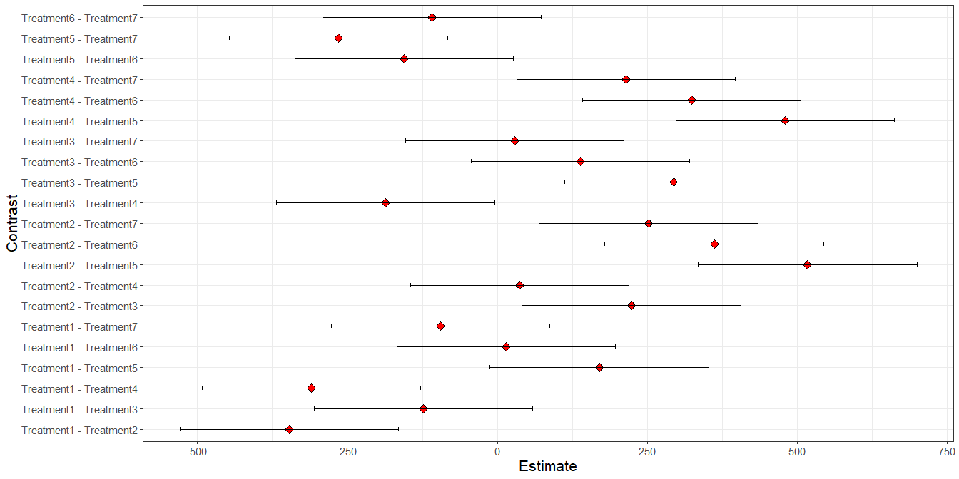

## Best treatment per location

### For every woreda, what are the 3 best treatment?

* Grain

best_comb<-yield_location_trt %>% select(Woreda, Treatment, mean_GY_kg_ha) %>%   
 group_by(Woreda) %>%  
 slice_max(mean_GY_kg_ha, n=3)  
knitr::kable(best_comb)

|  |  |  |
| --- | --- | --- |
| Woreda | Treatment | mean_GY_kg_ha |
| Boloso Bombe | 2 | 1166.667 |
| Boloso Bombe | 4 | 1155.000 |
| Boloso Bombe | 3 | 1098.333 |
| Boloso Sore | 2 | 1279.000 |
| Boloso Sore | 4 | 1190.000 |
| Boloso Sore | 7 | 1051.333 |

* Stover

best_comb<-yield_location_trt %>% select(Woreda, Treatment, mean_SY_kg_ha) %>%   
 group_by(Woreda) %>%  
 slice_max(mean_SY_kg_ha, n=3)  
knitr::kable(best_comb)

|  |  |  |
| --- | --- | --- |
| Woreda | Treatment | mean_SY_kg_ha |
| Boloso Bombe | 2 | 983.3333 |
| Boloso Bombe | 4 | 973.3333 |
| Boloso Bombe | 6 | 719.6667 |
| Boloso Sore | 2 | 1276.6667 |
| Boloso Sore | 7 | 1239.3333 |
| Boloso Sore | 5 | 1016.0000 |